KGiSL Institute of Technology

(Affiliated to ANNA University, Chennai and Approved by AICTE, New Delhi)

365, KGiSL Campus, Thudiyalur Road, Saravanampatti Coimbatore – 641035

**Department of Artificial Intelligence and Data Science**

**Name**

**Register Number Regulation**

**: Hari Darsan C**

**: 711721243029**

**: R-2021**

**Branch**

**: B.Tech -Artificial Intelligence and Data Science**

**Project Title**

**: Smart Water System**

**Semester/ Year**

**: V / III**

**Project Title:** Smart Water System

**Phase 3:** Development Part 1

# Configuring the IoT Sensors:

Install the sensors in public places where we want to monitor water consumption. Ensuring that they are securely mounted and connected to a power source if required.

# Suitable Flow Meters:

* Select appropriate flow meters based on flow rate, accuracy, and compatibility.
* Consider types like ultrasonic, electromagnetic, or turbine meters.
* Ensure the selected meters meet your project requirements.

# Install Flow Meters:

* Install meters in desired public places, ensuring proper connections.
* Professional installation may be necessary for accuracy and compliance.
* Securely mount meters to prevent tampering or damage.

# Calibrate Flow Meters:

* Calibrate meters for precise measurements using reference standards.
* Adjust settings to match actual flow rates accurately.
* Regular calibration ensures consistent and reliable data.

# Configure Sensor Parameters:

* Access meter settings and adjust parameters, e.g., sampling rate, units.
* Tailor configurations to project-specific requirement
* Confirm parameters align with your desired data output.

# Power Supply:

* Provide stable power sources for meters, either battery or continuous.
* Ensure power supply reliability to prevent data loss.
* Battery-powered meters may require periodic battery replacement.

# Data Output Format:

* Determine the format of data output, digital or analog.
* Prepare necessary adapters to interface with IoT sensors.
* Ensure compatibility with your data-sharing platform.

# Data Transmission Protocol:

* Choose a suitable communication protocol for data transmission.
* Popular options include MQTT, HTTP, or LoRaWAN.
* Match the protocol with your IoT platform's requirements.

# Integration with Data-Sharing Platform:

* Integrate flow meters with your selected data-sharing platform.
* Configure the platform to receive and process data from sensors.
* Provide the necessary sensor identification and communication details.

# Testing and Validation:

* Conduct thorough tests to verify meter accuracy.
* Compare sensor data with manual measurements for validation.
* Address any discrepancies to ensure data reliability.

# Remote Monitoring and Maintenance:

* Set up remote monitoring for real-time performance tracking.
* Enable alerts for sensor malfunctions or irregular data.
* Maintain a robust system for long-term reliability.

# Python Script:

Timport time import requests import json

# Replace with your own credentials API_KEY = "your_api_key" DEVICE_ID = "your_device_id"

# Replace with the URL of your data-sharing platform DATA_SHARING_PLATFORM_URL = "https://your-data-sharing- platform.com/api/v1/data"

# Function to simulate reading from a water consumption sensor def read_water_consumption():

# Simulate reading from a sensor

return 100 # 100 units of water consumption

# Function to send data to the data-sharing platform def send_data_to_platform(data):

headers = {

"Content-Type": "application/json", "Authorization": f"Bearer {API_KEY}"

}

response = requests.post(DATA_SHARING_PLATFORM_URL, headers=headers, data=json.dumps(data))

if response.status_code == 200: print("Data sent successfully")

else:

print(f"Failed to send data: {response.text}") # Main loop

while True:

# Read water consumption data water_consumption = read_water_consumption()

# Prepare data to be sent data = {

"device_id": DEVICE_ID, "water_consumption": water_consumption, "timestamp": int(time.time())

}

# Send data to the data-sharing platform send_data_to_platform(data)

# Wait for some time before reading the sensor again time.sleep(60) # 1 minute

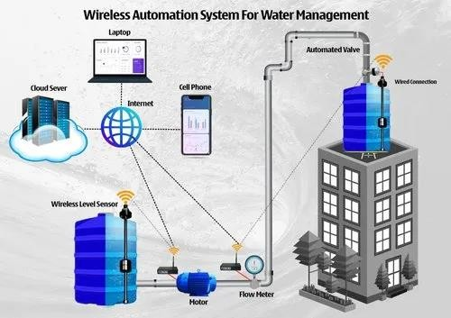

# Conclusion :

It emphasizes critical factors such as security, scalability, and data insights. Ensuring regulatory compliance, user-friendly reporting, and robust maintenance are vital for long-term success. This project holds the potential to enhance water resource management and contribute to sustainability in public places.